Audrey Hall
4/18/15
Dr. Kate Lechler
English 351
A Beast By Any Other Name
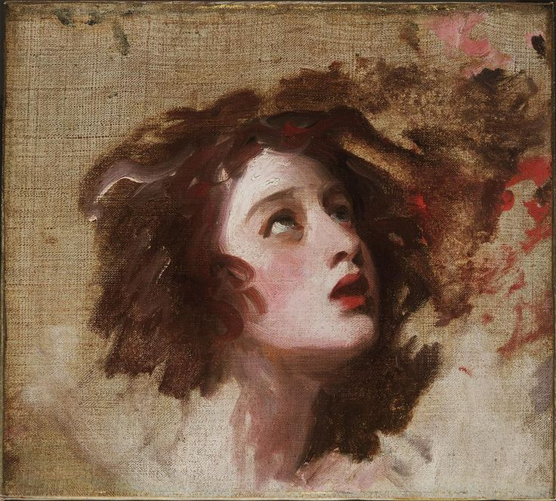
“The spell breaks when someone who truly loves me says my name,” says the Beast.
Belle looks from his hefty thick goat legs to his misshapen face, a mish-mash of wolf-bear-snake, with horse’s ears pricking towards her over golden reptilian eyes.
“I’ll do anything to find my father,” Belle says. She has come too far to find her father and not even a witch’s curse will stop her. “So what’s your name?”
Figure 1 Portrait of Emma Hart by George Romney
“Bram,” he says. One of the wings on his back is clearly broken, sagging sideways and down, feathers drifting wherever the wind blows. The other wing is upright, jet black, and stiff.
“Bram,” Belle says experimentally. Nothing happens and the Beast’s broken wing sags even more. “You know what happened to my father, Bram?”
The Beast nods, multiple eyelids clicking into place over his eyes, as though hiding his face.
“I’ll tell you, within a week, I promise,” he says. Belle grimaces, but nods slowly.
“You do that,” she says. “And we’ll work on breaking the spell.”
The tremendous cheer that follows her statement makes Belle jump. Glancing around her, she remembers the chorus of palace servants, now palace animals, surrounding them in a vibrating throng. The Beast’s man-at-arms, a stout bristling boar, trots forward.
“We thank you, gracious lady!” He oinks. The rest of the animals follow suit. An interesting experience it is, accepting praise from skinks who come up to her waist, but Belle smiles at everyone. Only after the host of creatures retires is she faced once more with the Beast, whose face is all grotesque animal features and no discernible emotion.
“How shall we entertain ourselves, lady?” He asks.
“You’re a prince, right? You’ve been trained with swords and bows and the like?” Belle asks, looking down at her father’s sword, strapped to her belt. The Beast nods slowly when she looks up. “Teach me.”
“Teach you to use a sword and bow?” His face might be impassive through all the curls and scales, but his voice is incredulous. Belle draws her sword and points it at him.
“When I’m free, I’m going to find my father, in whatever way I have to. I will not rest!” she says fiercely.
The Beast stares at her.
“Well?” Asks Belle, feeling a little embarrassed at having drawn her sword for little more than a blank stare. The Beast shakes himself, looks down, exhales.
“I’ll teach you,” he finally agrees, gesturing with a giant paw. “Come this way, lady.”
“It’s Belle,” she corrects, walking alongside him towards a courtyard filled with weeds and a lonely fountain, and stopping there. “Didn’t we cover the first names already?”
“Belle. Stand here. Lift your sword point up. You leave yourself open to attack when you drop your guard too low. Put your feet like this,” he uses one goat hoof to nudge her left foot forward and her right foot over. “Standing like this provides you balance. Find your center of gravity in your torso and pelvis, and keep your shoulders square over your feet. Good balance and a proper guard will prevent you from falling.”
And so Belle’s training begins. The Beast instructs her in sword-fighting, pulling out a practice dummy for her to practice strikes on, and eventually taking up his own sword to match blades with her in practice bouts. Belle pursues her training with dogged determination, imagining her father’s fate balancing on the edge of every attack. She lands a blow on the Beast, finally, and can’t contain her delight.
“I did it!” She says, astonished. The Beast looks equally surprised, glancing down at his tree trunk of a torso, where blood is starting to drip. Belle puts her hands on her hips, knuckles resting on the padding the Beast insists she wear. “Now will you wear padding too?”
“I suppose I should,” says the Beast. He smiles, not without fang, and Belle goes in search of bandages, grinning to herself too.
“Stand the same way when using a bow,” the Beast instructs, pushing one thick claw gently into the small of her back to make her stand straight. “Nock your arrow here. Put one finger above the shaft and these two fingers below. Pull back, straight back. Lift your elbow up. Sight down the arrow and… shoot.” They watch her arrow soar together, whistling sharply all the way into the dirt.
The Beast clears his throat. Belle smacks his hairy bicep with her bow and draws another arrow from her quiver, informing him,
“Laugh at me and I’ll use you for target practice.” But Belle misses again and again, until her quiver is empty. She puts her hands on her hips and tilts her head back up at the sky, frustration brimming like water lapping over the edges of a too-small cup. Images of her father reappear in her mind and she swallows hard. This is all just working towards finding him, she promises herself, and looks back down.
The Beast is kneeling in the dirt in front of the target, using two claws to gently pry each arrow from the earth, contorted body held carefully in order to avoid breaking any arrow shafts. The courtyard is caught in silence as he stands, all of the arrows lying pristine in his huge palm. He brings them back to her, odd pupils moving to her face and away as he lays them in her hand. The dirt and mud on his claws catches roughly on Belle’s palms as she takes her arrows back. Belle feels the weight of his claws long after he drops his hands away.
“Thank you, prince,” she says, remembering who this cursed Beast once was.
“I thought we were on first name terms,” replies the Beast. Belle startles, laughs.
“You’re right. Thank you, Bram.”
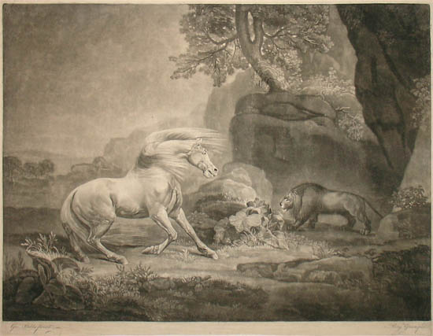
And so the days go on. Bram teaches Belle how to use a sword, use a bow, how to use a chessboard to humiliate his entire palace staff. He instructs her in jousting from a distance, as his horses can no longer tolerate his presence. They see the lion’s mane now, the snake eyes, the monster alone. Belle spends one day reacquainting him slowly and carefully with his stables. Seeing Bram’s face light up when his great warhorse eats once more from his hand, Belle wraps her arms around herself and smiles too. His smile, however fanged, is infectious.
Figure 2 The Horse and the Lion by George Stubbs
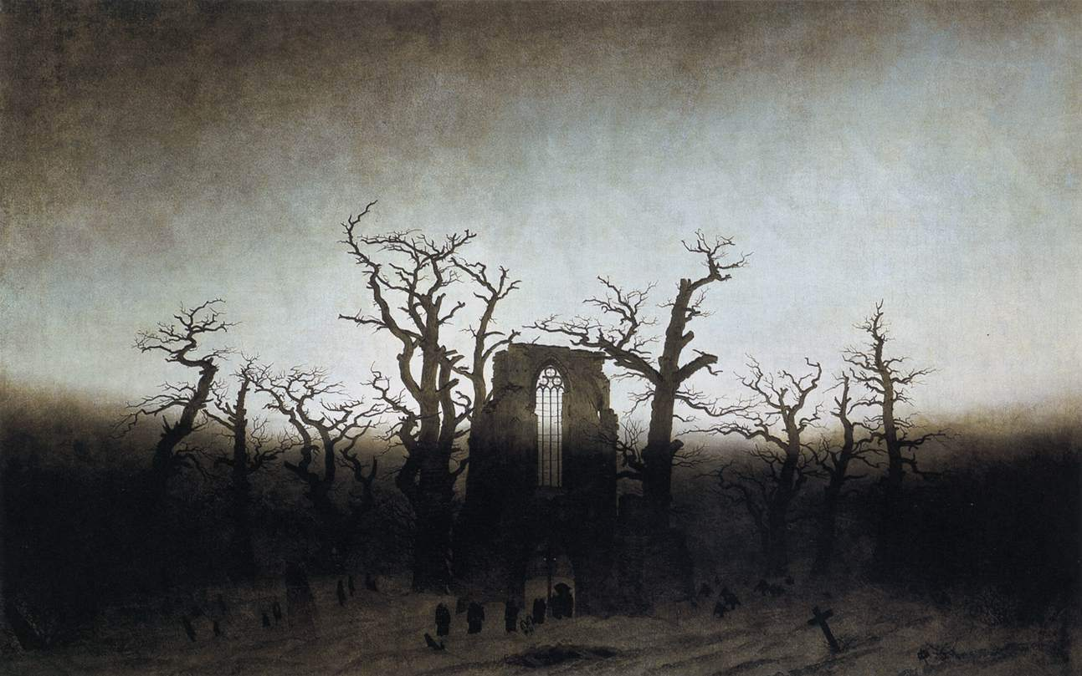
Belle is given full reign of the castle. She walks uninterrupted throughout the halls, the courtyards, the stables, the enormous ballrooms. She walks beneath the wall of thorns that

surround the castle, grown so high that even the sky seemed to shrink away for fear of being pricked. But she does not walk behind the castle, where the wall of thorns cup a tall stone monument, where the ground is littered with gravestones, for the Beast expressly forbid it.
Figure 3 The Abbey in the Oakwood by Casper David Friedrich
Normally, Belle would chafe at such an order. But the spell requires the two of them to get along, at least, and so she humor him with obedience as he humors her with education. She does not go near the pale patch of ground forbidden to her. But the days pass and the end of the week approaches. The monument looms as her father’s fate does.
The final morning, she dresses herself and takes herself down the greens toward this empty hill, curiosity swallowing caution. As she comes closer, Belle sees gravestones and head markers everywhere. They are Bram’s ancestors and Belle studies each headstone, wondering what Bram could have to hide down here.
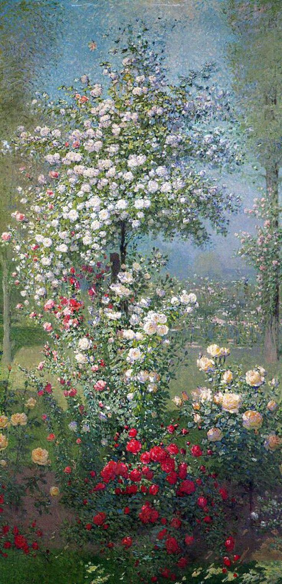
At the end of the pale hill, in front of the towering gray monstrosity, lies a startling patch of color. Belle looks at the roses growing there and feels them on her skin, even though she stands several feet away. There is freshly-dug dirt beneath the roses, a recently-dug grave, and Belle sees something gleaming beneath the roses, the sight catching at her heart like the grip of thorns on delicate fingers. She falls to her knees, reaches out, and touches her father’s helmet, his house’s insignia fading away on its brow. There is a little dent in the brow where Belle once knocked his helmet askew. The metal is bitingly cold.
Figure 4 Flowers by Ernest Quost
Belle drops the helmet. She digs her fingers into the dirt and screams into his grave. The realization is like a sickness sinking into her gut, a shipwreck between her lungs; she can’t breathe. The world slows to a halt around her, the sun’s rise slower than the tears falling down her face.
She doesn’t hear the Beast’s approach, but she cries again at the sound of his voice.
“It was an accident, I swear, Belle,” he says. Belle grabs a fistful of the loose dirt and spins around, throwing the soil in the Beast’s face.
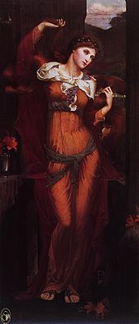
“If I could kill you, I would,” she says, voice cracking around the vowels. There’s a monster in her, as ugly as the one in front of her, clawing to get free. She almost draws her sword, almost. The metal warms within her grasp.
“I’m sorry, Belle,” begs the Beast, his broken wing tip drags on the ground as he backs away. “I’m so sorry. It was an accident, I didn’t mean to kill him. I never wanted any of this! If I could fix it, bring him back, I’d do it, I’d do anything.”
Belle puts her hands over her ears, Bram’s betrayal too much to bear, but his words find purchase elsewhere. Midnight opens up like a black hole and into the cemetery steps a Witch, blood-red dress sweeping out around her legs like a grotesque red river. Bram steps between the Witch and Belle, donkey’s tail lashing nervously. Belle inhales; the air smells like smoke. This is the Witch who cursed Bram.
Figure 5 Morgan Le Fay by John Spencer Stanhope
“Was that an apology I heard, proud prince?” Asked the Witch, teeth glittering.
“I didn’t want to kill him! It was an accident, and you knew it when you cursed me,” Snaps the Beast, but he’s looking back at Belle, whose confusion and sorrow renders her mute once more.
“Excuses,” purrs the Witch. The Beast looks from the Witch to Belle and back, thick claws burying themselves in his hairy palms. When he speaks again, his voice is gravel.
“You have dark magic. You can turn back time, bring back the dead. Bring back her father.” Belle gasps, the sickness in her stomach lurching upwards. The Witch laughs.
“Silly Beast! I’m all-powerful, true, but death can’t be cheated. You’ll need a sacrifice first.”
“Take me, then,” says Bram.
“What?” Says Belle. Her fingers dig into the earth.
“What?” Says the Witch, voice lifting in mockery.
“If you need a sacrifice, take me in his place. Belle… Belle can have her father back.” Bram’s not looking at her, but when Belle scrambles to her feet, he flinches away from her. Belle comes between Bram and the Witch, throat caught with spasms on the words she says.
“No one else is dying!”
“I could do it anyway,” observes the Witch, as the Beast grabs Belle’s arm, trying to move her aside. “But the apology was nice, dear Beast.”
“You’ll free us?” Asks Belle, elbowing Bram’s hands away. “Don’t touch me,” she tells him, and he falls away like a shadow, face closing.
“Oh, no. His curse is broken with his name spoken by one who loves him. I was very specific. But it’s nice to see you have fallen so low already.” The Witch steps away into the night, leaving the rising sun and morning much warmer without her smug malice. Belle staggers away from Bram and kneels before her father’s grave once more. The sun is fully in the sky before either of them speak again.
“I swear it was an accident, Belle,” whispers the Beast. “We were hunting. I mistook him and his horse for a prize buck and shot him. It was an accident.”
Belle picks up her father’s helmet silently, as Bram kneels beside her.
“I would do anything to take it back, I tried. I’m trying to make up for it, I’ve learned so much from you already, just trying to be someone you could care for… I am truly sorry.”
Belle clears her throat, silencing him. She rubs her thumbs over the dent in her father’s helmet, sets it on her knees, and looks at Bram, with his curling ram’s horns and reptilian eyes. The Beast is crying, she sees, deep wet tunnels down his furry cheeks.
“You’re my friend. You’ve been so good to me,” she says. “And… you made a terrible mistake, one I can’t just forgive right away.”
The sun throws golden halos around both of them, the cold air lifting like a veil. With every morning dew drop, Belle breathes deeper.
“But, maybe. Maybe one day… I think, I could try.”
The Beast holds her gaze and sets a paw down on top of the grave’s dirt, claw tips immersed in the same soil staining Belle’s hands.
“I’ll be worthy of your forgiveness then,” he vows. “I swear it.”

Works Cited Page
Lang, Andrew, ed. "Beauty and the Beast." The Blue Fairy Book. New York: Dover, 1965.
(Original published 1889.)

